Assignment 2 Report

Workshop

# Output

## Output 1 (Empty Files):

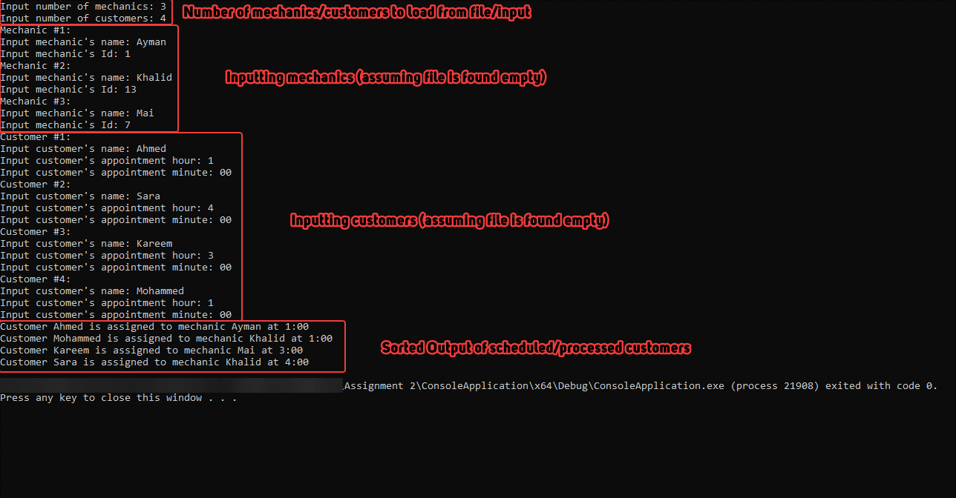

## Output 2 (Mechanics File Filled):

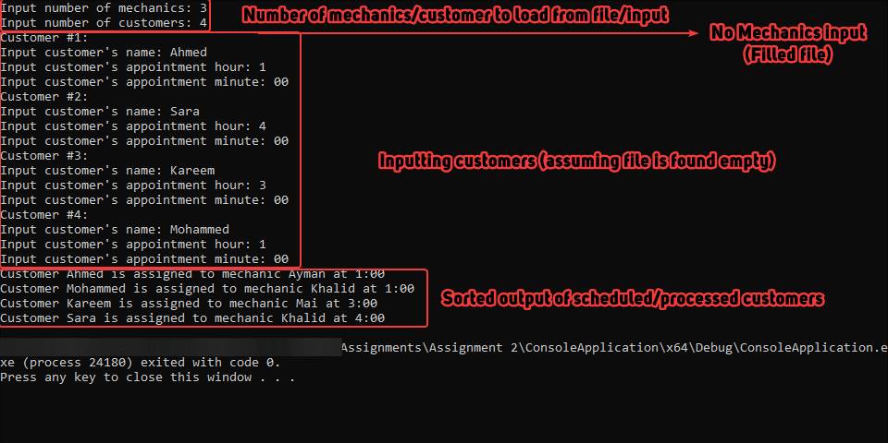

## Output 3 (Mechanics and Customers Files Filled):

# Notes/Remarks

1. I may have deviated a little bit from the exact assignment requirement but it was for the purpose of producing better and cleaner code.
2. The data manager class functions (load_mechanics_from_file and load_customers_from_file) are very horribly done but they do work. Each different mechanic/customer is separated by a ‘#’ and each data count (relative line number) corresponds to a specific data variable. Minutes and Hours were done using even and odd number of line and the counter for the mechanic was ignored since it is already incremented when adding the read appointments. Those 2 functions are extremely fragile.
3. At some parts, the customers queue was converted into an array for sorting purposes only and was then converted back into a queue, since the data was needed multiple times to sort it, I had to use a different data type.
4. workshop::process_customers goes through all the customers, checks if their appointment is available.
   1. If available, the mechanic adds the appointment, the customer sets the mechanic’s id, the queue pops the customer and pushes it back in (in order to access the next customer).
   2. If not available then the loop continues to the next mechanic till an available one is found.
   3. If non are available, then the customer gets rejected, a message gets displayed, and the customer is popped.
5. Extensive efforts were made to ensure that there is no memory leaks, I don’t know if that was required or not but it felt like the right thing. There should be no memory leaks in this pogram.